**WIPRO EXERCISE**

**Steps to build my-website**

**Step 1: Create Project Directory**

Open your terminal and run:

mkdir my-website

cd my-website

**Step 2: Create Website Content**

Create a file named index.html with the following content:

**File: index.html**

<!DOCTYPE html>

<html lang="en">

<head>

<meta charset="UTF-8">

<title>My Docker Website</title>

</head>

<body>

<h1>Welcome to My Docker Website!</h1>

<p>This is a simple static website hosted using Nginx and Docker.</p>

</body>

</html>

**Step 3: Create Dockerfile**

Create a file named Dockerfile in the same directory:

**File: Dockerfile**

# Use the official Nginx image from Docker Hub

FROM nginx:alpine

# Copy the website files to the Nginx HTML directory

COPY index.html /usr/share/nginx/html/index.html

# Expose port 80 for the web server

EXPOSE 80

# Start Nginx when the container launches

CMD ["nginx", "-g", "daemon off;"]

**Step 4: Build and Run the Docker Container**

1. **Build the Docker image:**
2. docker build -t my-website .
3. **Run the Docker container (map container port 80 to host port 8080):**
4. docker run -d -p 8080:80 --name my-website-container my-website

**Step 5: Access the Website**

Open your browser and go to:  
**👉** [**http://localhost:8080**](http://localhost:8080/)  
You should see the "Welcome to My Docker Website!" page.

**Step 6: Stop and Clean Up (Optional)**

1. **Stop and remove the container:**
2. docker stop my-website-container
3. docker rm my-website-container
4. **Remove the Docker image:**
5. docker rmi my-website

**SCREENSHOT OF THE STEPS  
STEP-1**

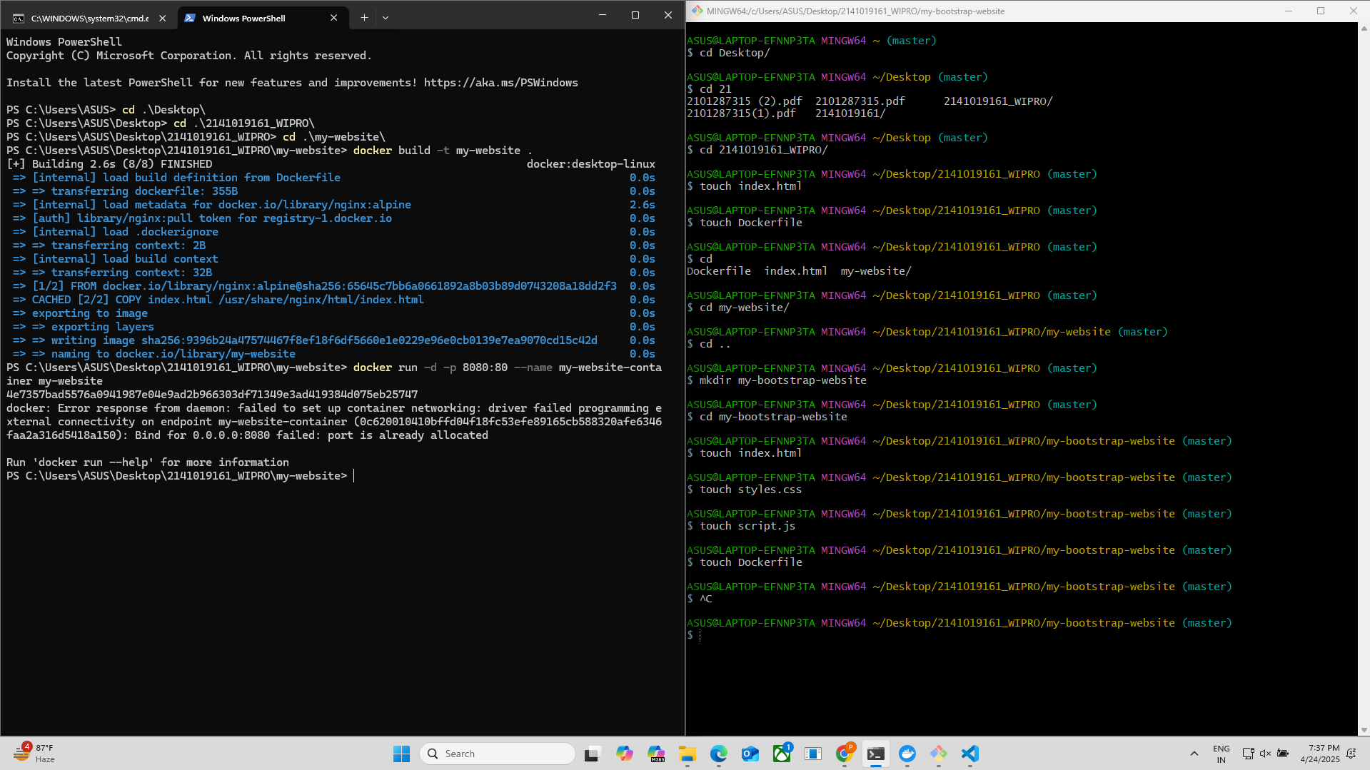

**STEP-2**

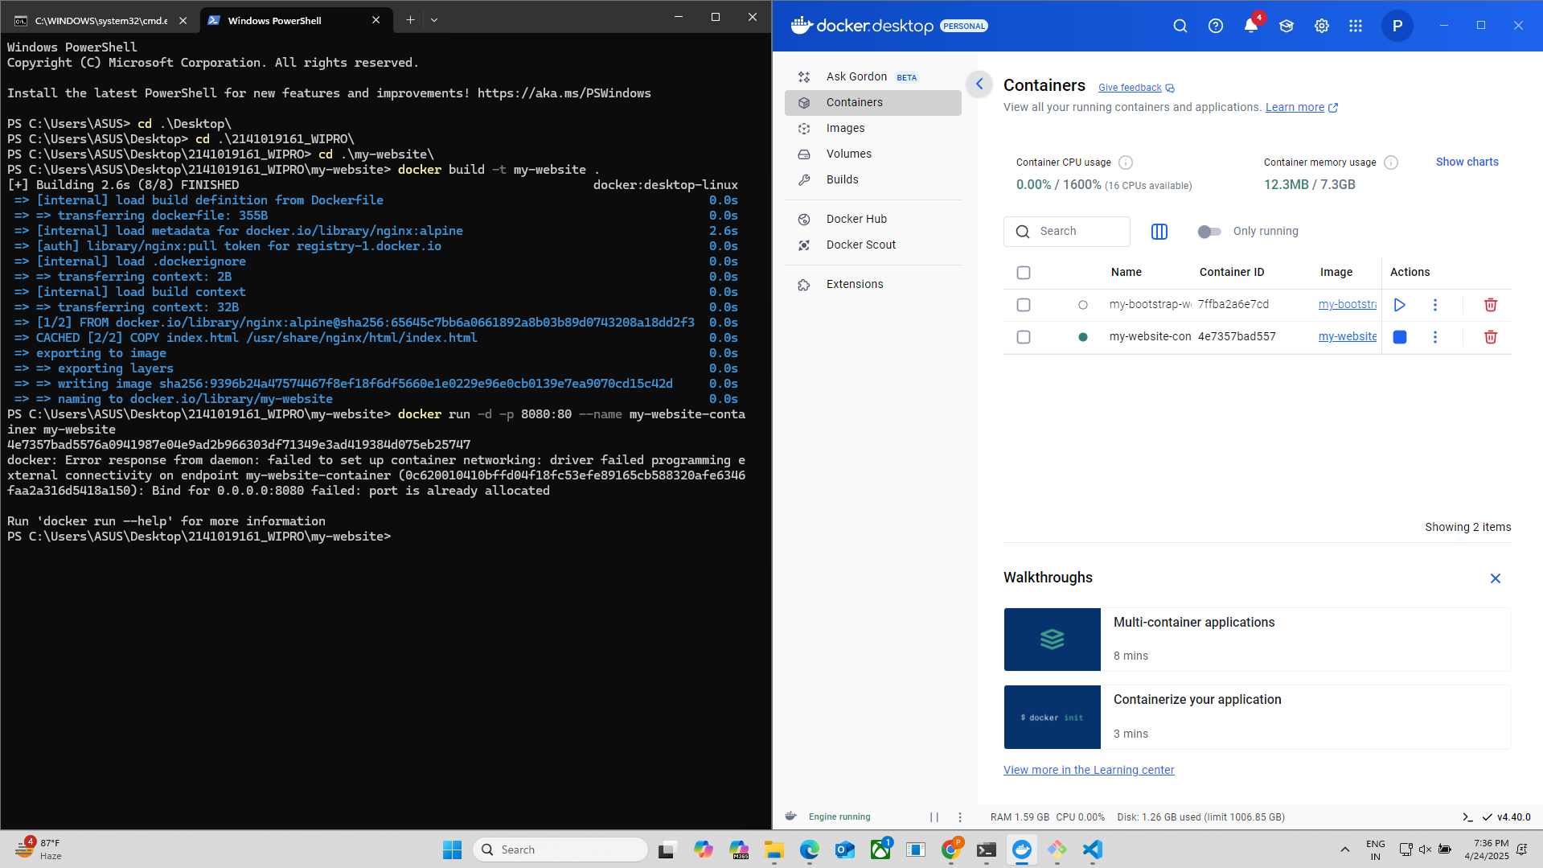

**STEP-3**

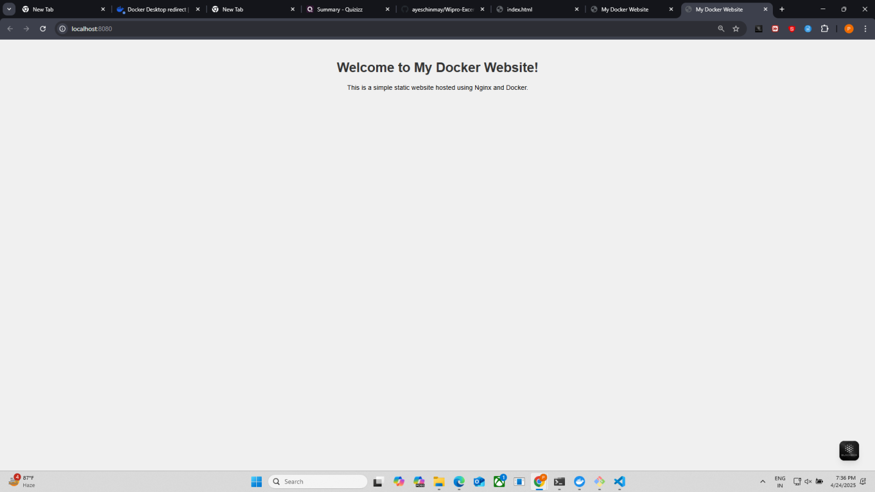

**Steps to build my-bootstrap-website**

### ****Step 1: Create Project Directory****

Open your terminal and run:

mkdir my-bootstrap-website

cd my-bootstrap-website

### ****Step 2: Create Website Files****

#### ****File:**** index.html

<!DOCTYPE html>

<html lang="en">

<head>

<meta charset="UTF-8">

<title>My Docker Website</title>

<meta name="viewport" content="width=device-width, initial-scale=1">

<!-- Bootstrap CSS CDN -->

<link href="https://cdn.jsdelivr.net/npm/bootstrap@5.3.0/dist/css/bootstrap.min.css" rel="stylesheet">

<!-- Custom CSS -->

<link rel="stylesheet" href="styles.css">

</head>

<body>

<div class="container text-center mt-5">

<h1>Welcome to My Docker Website!</h1>

<p class="lead">

This website uses Bootstrap, jQuery, and custom CSS, hosted with Nginx and Docker.

</p>

<button id="toggleButton" class="btn btn-primary mt-3">Toggle Message</button>

<p id="message" class="mt-3 d-none">Hello! This message was toggled using jQuery.</p>

</div>

<!-- jQuery CDN -->

<script src="https://code.jquery.com/jquery-3.7.1.min.js"></script>

<!-- Custom JS -->

<script src="script.js"></script>

</body>

</html>

#### ****File:**** styles.css

body {

background-color: #f8f9fa;

font-family: Arial, sans-serif;

}

h1 {

color: #343a40;

}

.lead {

color: #6c757d;

}

#### ****File:**** script.js

$(document).ready(function() {

$('#toggleButton').click(function() {

$('#message').toggleClass('d-none');

});

});

### ****Step 3: Create Dockerfile****

**File: Dockerfile**

# Use the official Nginx image from Docker Hub

FROM nginx:alpine

# Copy website files to the Nginx HTML directory

COPY index.html /usr/share/nginx/html/

COPY styles.css /usr/share/nginx/html/

COPY script.js /usr/share/nginx/html/

# Expose port 80 for the web server

EXPOSE 80

# Start Nginx when the container launches

CMD ["nginx", "-g", "daemon off;"]

### ****Step 4: Build and Run the Docker Container****

1. **Build the Docker image:**

docker build -t my-bootstrap-website .

1. **Run the Docker container:**

docker run -d -p 8080:80 --name my-bootstrap-website-container my-bootstrap-website

### ****Step 5: Access the Website****

Open your browser and visit:

📍 [**http://localhost:8080**](http://localhost:8080/)

You should see a Bootstrap-styled page with a button and a message that toggles using jQuery.

### ****Step 6: Stop and Clean Up (Optional)****

1. **Stop and remove the container:**

docker stop my-bootstrap-website-container

docker rm my-bootstrap-website-container

1. **Remove the Docker image:**

docker rmi my-bootstrap-website

**SCREENSHOT OF THE STEPS**

**STEP-1**



**STEP-2**

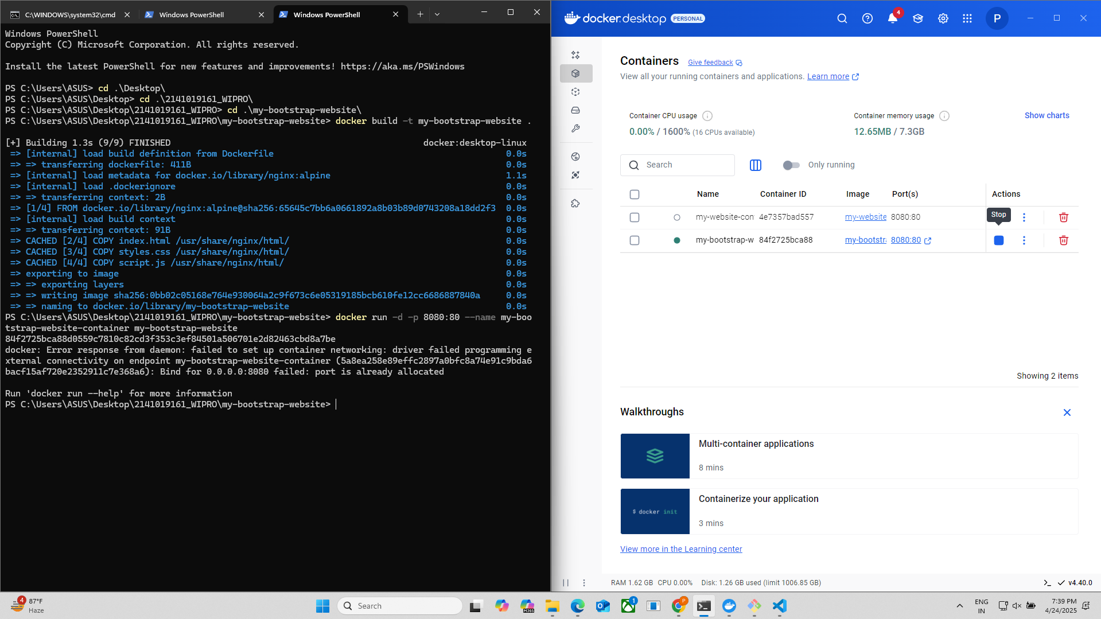

**STEP-3**

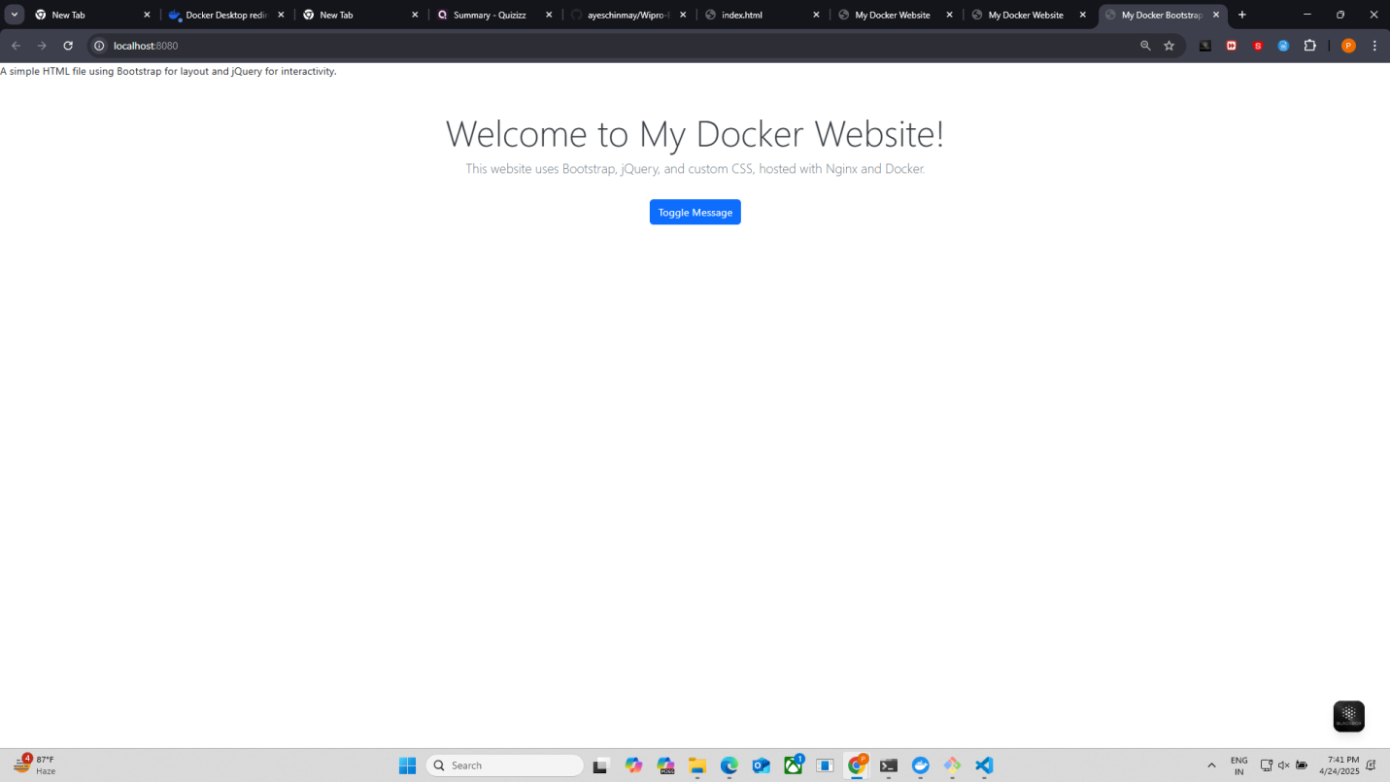

**STEP-4**

